# Lab 6: Make 2d Game

Harshaditya Sharma

22BAI1054

Gameplay in this video

https://drive.google.com/file/d/1z17XDv_B0fFQ7x7UTHDQ538Hxp9YkTLB/view?usp=sharing

1. Create a new 2d project

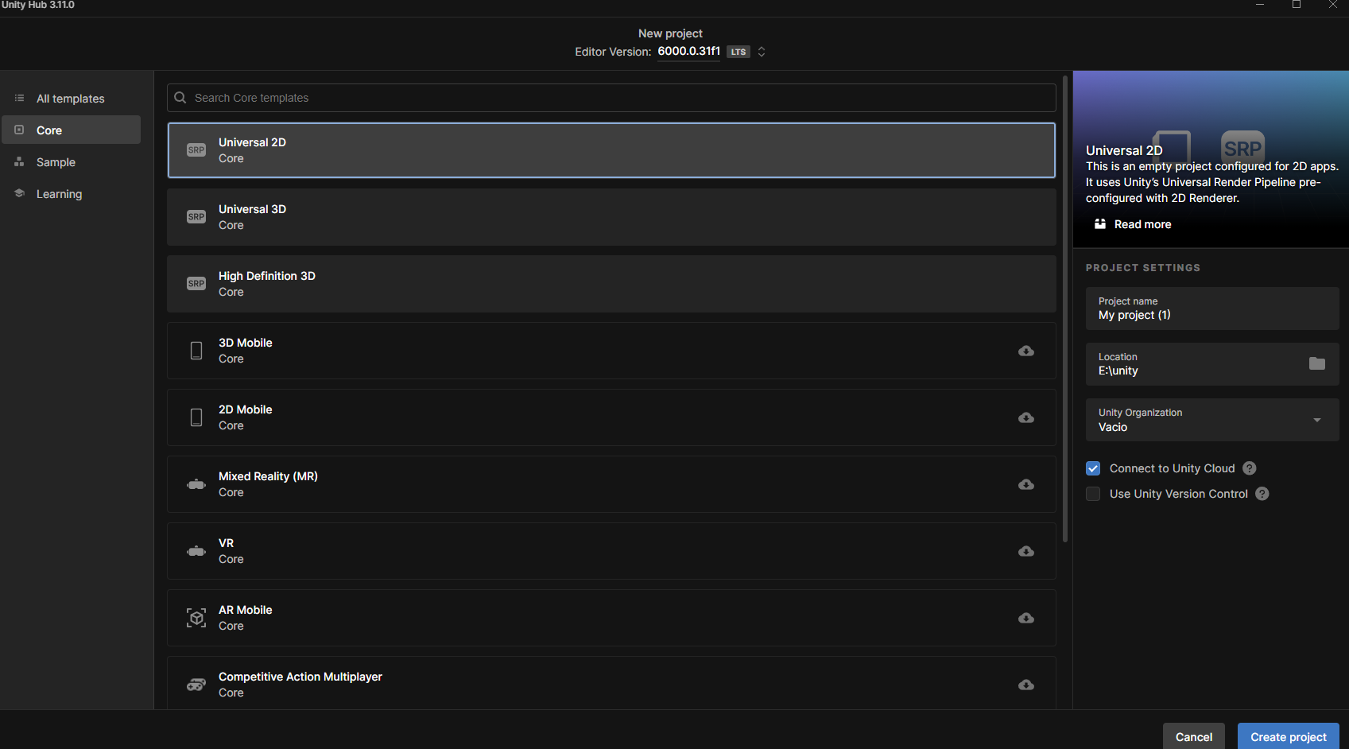

1. Create or download assets for the 2d game from the web store and import them
   1. Create a folder for sprites and add all your assets to it

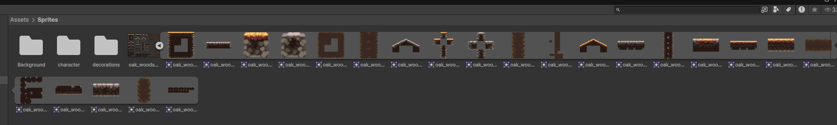

1. Import background layers and add them to your scene with proper layer order

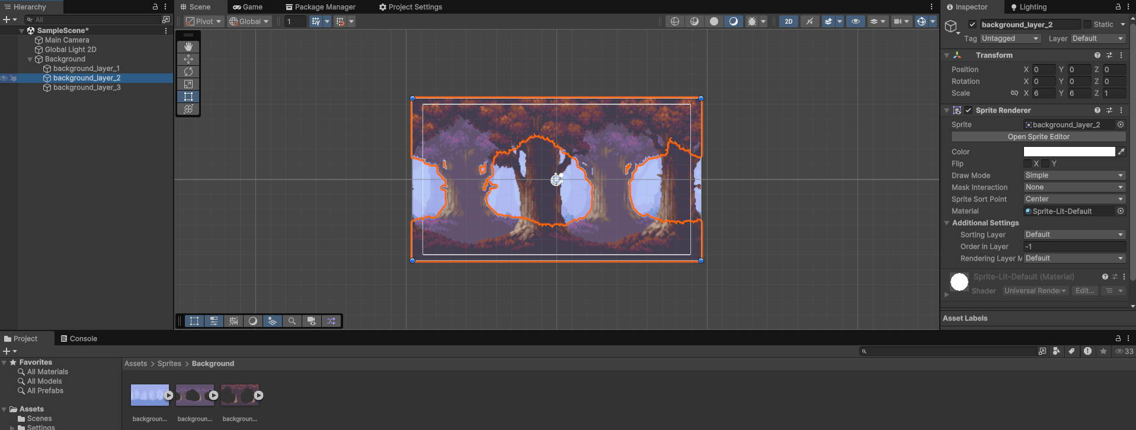

1. Add a character and setup animations for it.

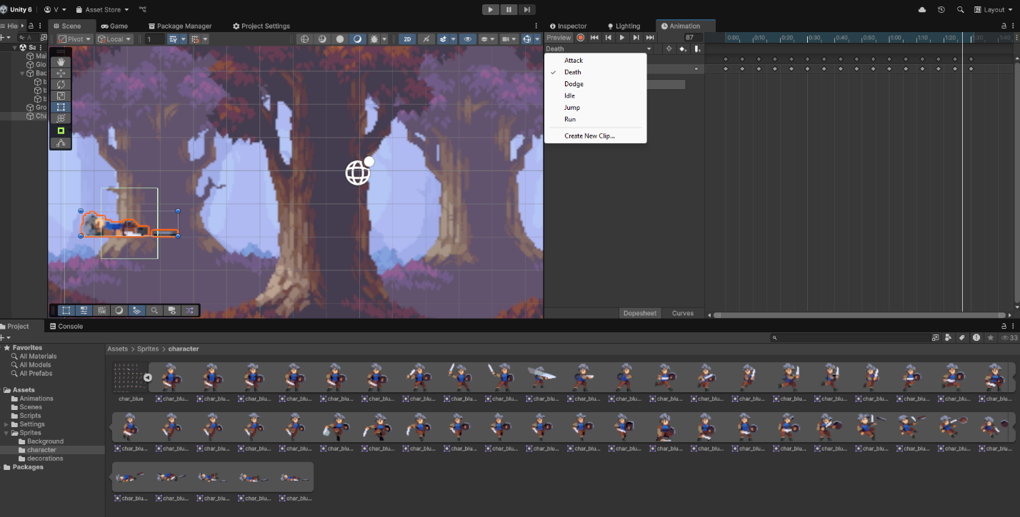

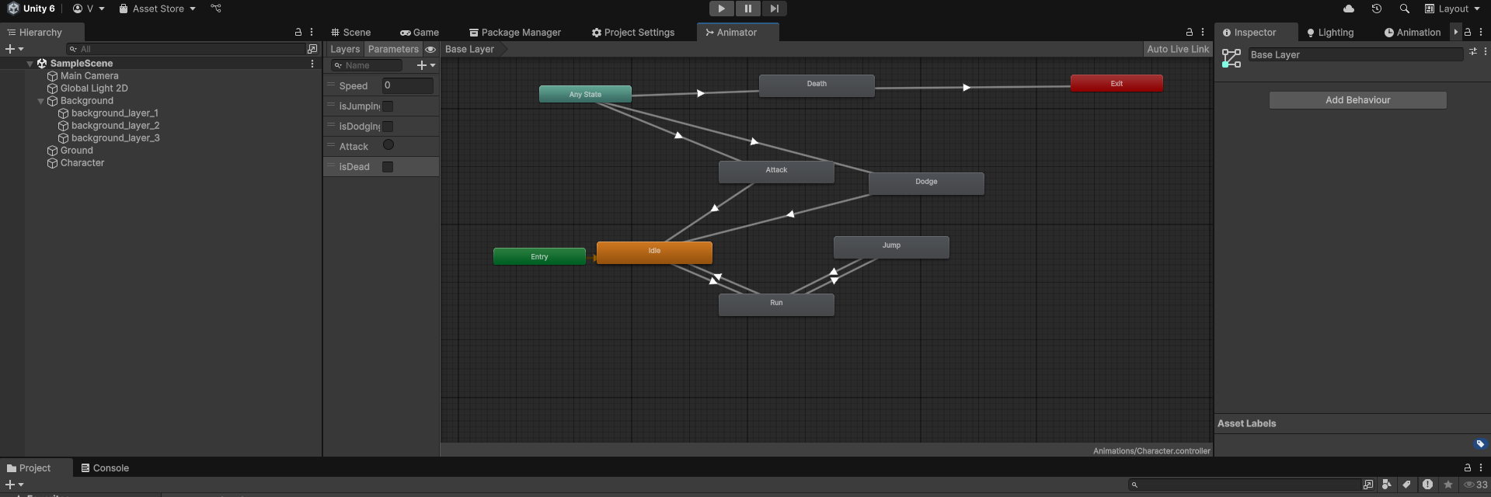

1. Setup Ground/Platform and enemies

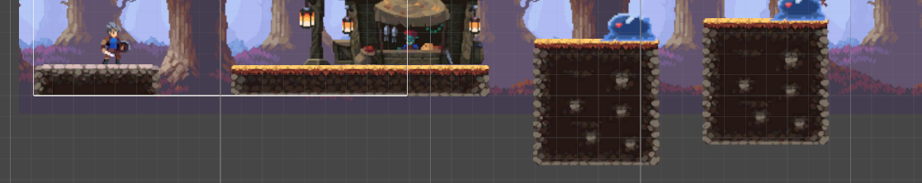

1. Setup Player Controller Script

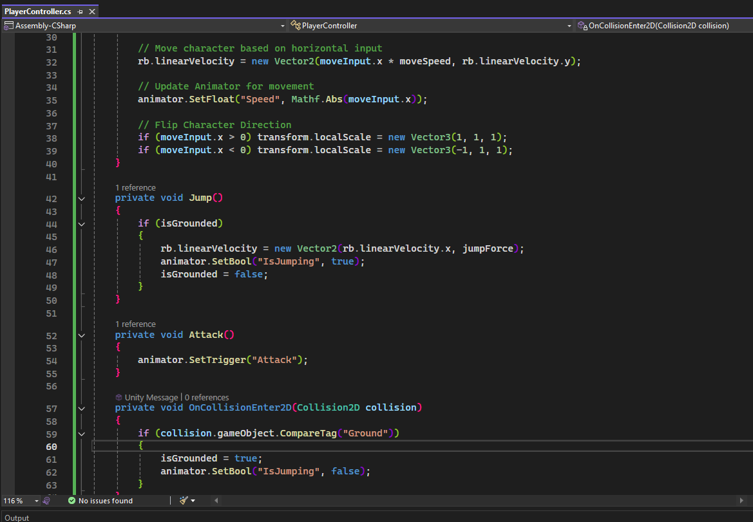

1. Setup Collectibles

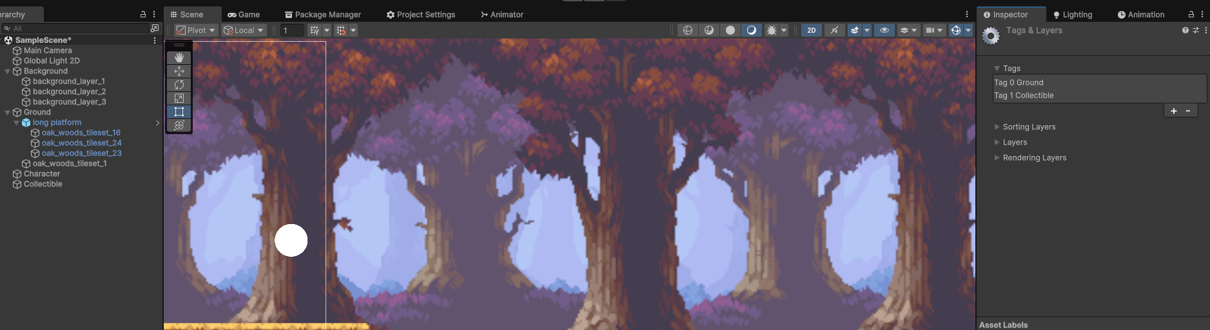

1. Setup UI

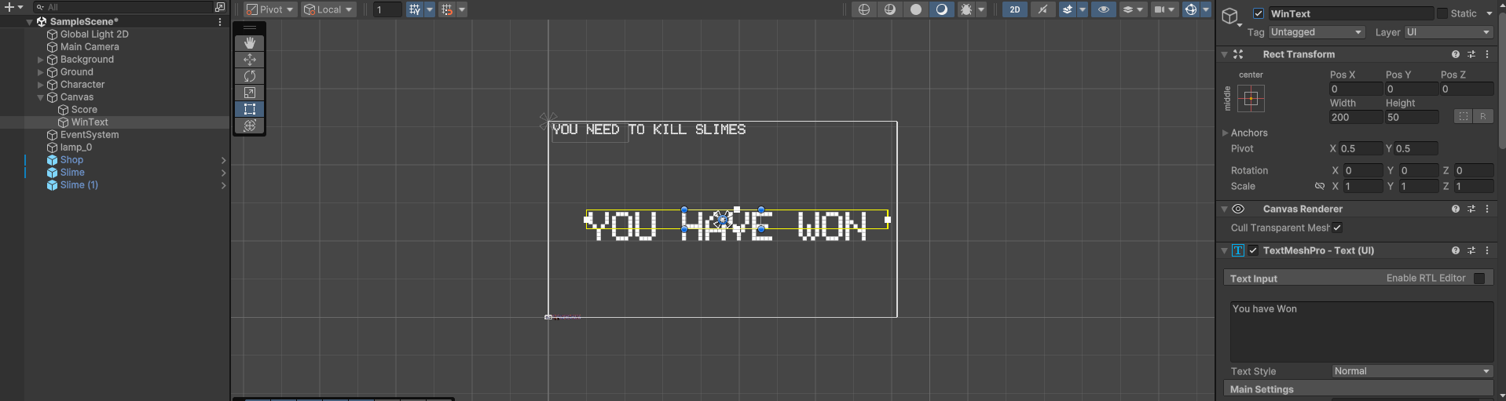

1. Add win/lose conditions.

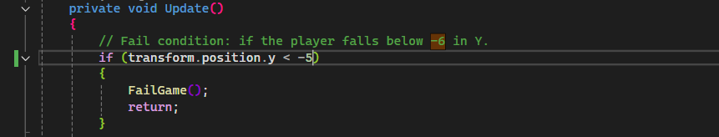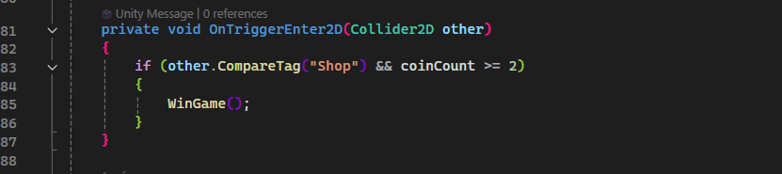

1. Play test the game.